Modelling ODEs
Mathematical models are the cornerstone of engineering. They allow us to take a real world system, and simplify it to a mathematical problem which can be solved. The advantage of mathematical models, is they allow us to predict how systems will behave without have to build and test them. Throughout this unit, we will be giving you contextualised engineering problems, which require modelling before you can complete the mathematics. This tutorial will provide some practice with some of the common modelling techniques we will expect you to use throughout the unit.
Considering we will be learning how to solve Ordinary Differential Equations (ODEs) from next week onwards, this tutorial will mainly focus on systems that can be described as an ODE, including mechanical and electrical problems.

ODEs in Standard Form
An ODE is an equation containing derivatives of one variable with respect to another variable eg. 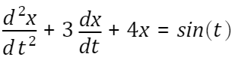. ODEs are most commonly written in standard form. For an ODE to be in standard form,
1. The dependant variable and all its derivatives must all be on the left hand side of the equation. The terms must be written from highest order derivative to lowest order.
2. Any remaining expressions go on the right hand side of the equation.
3. The coefficient of the highest order derivative must be 1.
The example given earlier abides by these rules, so it is in standard form.

Questions
Try converting the following ODEs into standard form.
1. 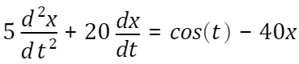
Ans: $\frac{d^{2}x}{{dt}^{2}}+4 \frac{dx}{dt}+8x=\frac{1}{5}cos⁡(t)$

2. 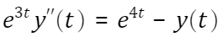
Ans: $y" +e^{-3t} y = e^{t}$

3. 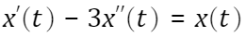
Ans: $x"-\frac{1}{3} x'+ \frac{1}{3} x=0$

Mechanical Problems
The main tool that is used for modelling mechanics problems is called a free body diagram. This is a diagram where all of the forces and torques (or moments) acting on a body are drawn. This diagram is then used in conjunction with Newton's Second Law in order to derive an equation of motion. Newton's Second Law states 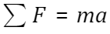. It also has a rotational equivalent: 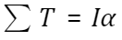, where is the rotational inertia of the object (how much it resists changes in rotational velocity), while is the rotational acceleration.
Also remember that there are differential relationships between kinematic properties. These are 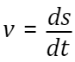, 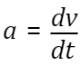for linear motion, and 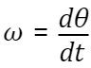, 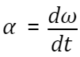for rotational motion. Because of this, mechanics problems can often be described using differential equations.
Some common forces that are found in such problems are spring forces 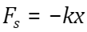, damping forces 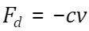, air resistance (drag) 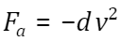, torques 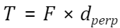and rotational damping 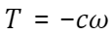.

Questions
For the following problems, draw a clear free body diagram (FBD). Then use Newton's Second Law (NSL) to describe an equation of motion for the object. Present the ODE in standard form.
1.
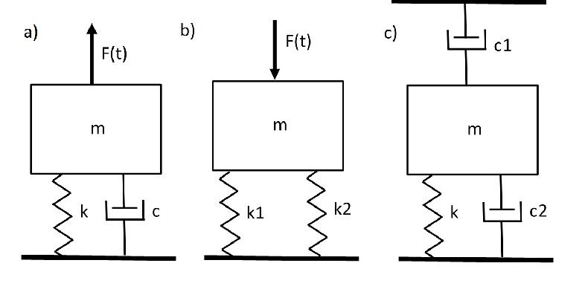

1 a)
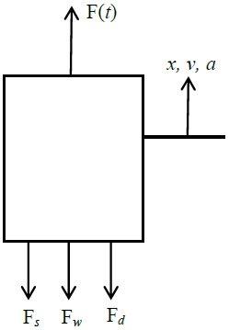
$$∑ F=ma$$
$$F\left(t\right)- F_{s}- F_{d}-F_{w}=ma$$
$$F\left(t\right)- kx- cv-mg=ma$$
$$F\left(t\right)- kx- cx'-mg=mx"$$
$$∴x"+\frac{c}{m}x'+\frac{k}{m}x= \frac{F(t)}{m}$$
Note: Can cancel weight force to measure x from Static Position.

b)
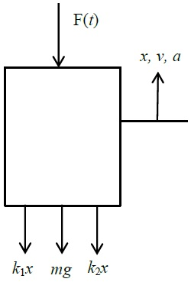
$$∑ F=ma$$
$$-F\left(t\right) - k_{1}x - k_{2}x-mg=ma$$
$$mx" + {(k}_{1}+k_{2})x=F(t)+mg$$
$$x" + \frac{k_{1}+ k_{2}}{m} (x)= \frac{F(t)}{m}$$

1 c)

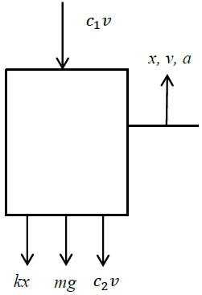

$$∑ F=ma$$
$$-c_{1}v - c_{2}v -kx-mg=ma$$
$$mx" + {(c}_{1}+c_{2})x'+kx=-mg$$
$$x" + \frac{{(c}_{1}+ c_{2})}{m} x'+ \frac{k}{m}x=0$$

2. An object of mass 'm' in freefall.
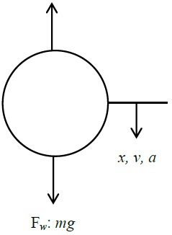

$$∑ F=ma$$
$$F_{w}-Fair =ma$$
$$mg - dv^{2}=ma$$
$$mv^{1}-dv^{2}=mg$$
$$v^{1}+\frac{dv^{2}}{m}=g$$
3. A helium balloon with a constant upwards buoyancy force.
3)
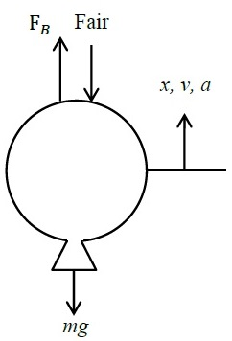

$$∑ F=ma$$
$$F_{B}-Fair -mg=ma$$
$$F_{B} - dv^{2}-mg=ma$$
$$ma+dv^{2}=F_{B}-mg$$
$$v^{1}+\frac{d}{m}v^{2}=\frac{F_{B}}{m}-g$$

4. A pendulum with damping (don't consider air resistance).
4)
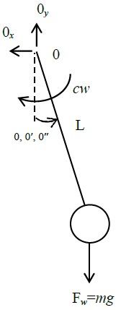

$∑ T_{0}=I_{0}∝$ where $∝ =θ''$
$$-cL^{2}w-mgL sinθ=mL^{2}∝$$
$$mL^{2}θ"+cL^{2}θ'+mgL sinθ=0$$
$$θ"+\frac{c}{m}θ'+\frac{g}{L} sinθ=0$$
Linearised: sin θ ≃ for small angles.
∴ $θ"+\frac{c}{m}θ'+\frac{g}{L}θ=0$
http://www.sharetechnote.com/html/DE_Modeling_Example_Pendulum.html
https://services.math.duke.edu/education/ccp/materials/diffeq/pendulum/pend1.html

Electrical Problems
Capacitors and indutors both have voltage-current relationships described by derivatives. Because of this, ciruits can often be described using ODEs. In order to analyse these circuits, there are 5 rules we need to apply.
1. Kirchoff's Voltage Law (KVL): 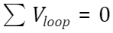
2. Kirchoff's Current Law (KCL): 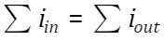
3. Ohm's Law: 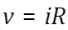
4. Capacitor: 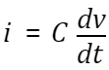
5. Inductor: 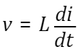

Questions
Describe the circuits below as ODEs in standard form. You may assume the power source in each case is a constant.
1.
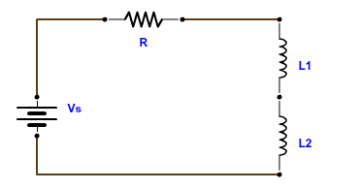

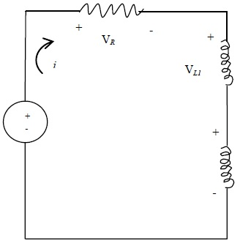
$$∑ V_{100p}=0$$
$$V_{S}-V_{R}-V_{L_{1}}-V_{L_{2}}=0$$
$$V_{R} = iR$$
$$V_{L} =L\frac{di}{dt}$$
∴ $V_{S}-iR -L_{1}\frac{di}{dt}-L_{2}\frac{di}{dt}=0$
$$(L_{1}+L_{2})i'+Ri=V_{S}$$
$$i'+\left(\frac{R}{L_{1}+L_{2}}\right)i=\frac{V_{S}}{L_{1}+L_{2}}$$

2.
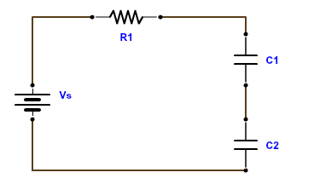

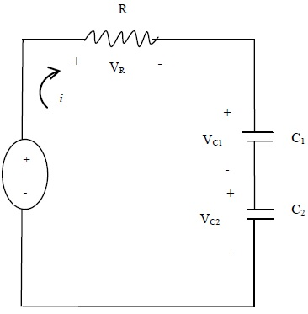

$$∑ V_{100p}=0$$
$$V_{S}-V_{R}-V_{C_{1}}-V_{C_{2}}=0$$
$$V_{R} = iR$$
$$i =C\frac{dV_{c}}{dt}$$
$$V_{C} =\frac{1}{C} \int{i dt}$$
$$V_{S}-iR -\frac{1}{C_{1}}\int{i dt-}\frac{1}{C_{2}}\int{i dt}=0$$
Assumes $V_{S}$is constant $→$ $-R\frac{di}{dt}- \frac{i}{C_{1}}-\frac{i}{C_{2}}=0$
∴ $i'+\frac{(C_{1}+C_{2)}}{{R C}_{1}+C_{2}} i=0$

3.
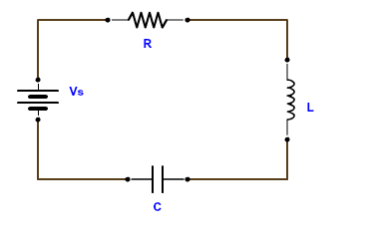

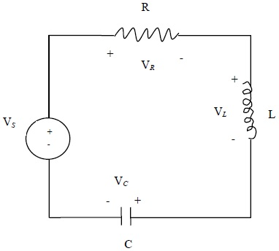

$$∑ V_{100p}=0$$
$$V_{S}-V_{R}-V_{L}-V_{C}=0$$
$$V_{R} = iR$$
$$V_{C} =L\frac{di}{dt}$$
$$V_{C} =\frac{1}{C} \int{i dt}$$
$$V_{S}-iR -L\frac{di}{dt}-\frac{1}{C}\int{i dt}=0$$
Assumes $V_{S}$is constant $→$ $-Ri'-Li"- \frac{1}{C} i=0$
$$i"+ \frac{R}{L} i'+ \frac{1}{LC} i=0$$

4.
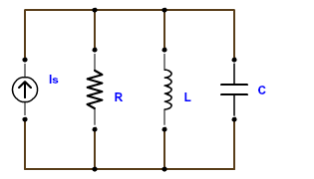
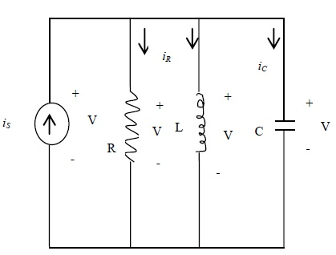
From KVL, Voltage must all be the same.
$$KCL= ∑ i_{IN}= ∑ i_{OUT}$$
∴ $i_{S}=i_{R}+i_{L}{+i}_{C}$
$$i_{R}=\frac{V}{R}$$
$V=L\frac{di_{L}}{dt}$ ∴ $i_{L}=\frac{1}{L}\int{V dt}$
$$i_{C}=C\frac{dv}{dt}$$
∴ $i_{S}=\frac{V}{R}+\frac{1}{L} \int{V dt}+C\frac{dv}{dt}$
$0=\frac{V'}{R}+\frac{V}{L}+CU"$ (assumes i_{S} is Constant.
∴ $V" +\frac{1}{RC}V'+\frac{1}{LC}V=0$

