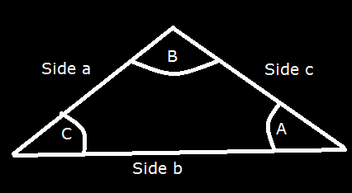
Sine and Cosine Law:
The Sine Law:
$\frac{a}{SinA}$ = $\frac{b}{SinB}$
The Cosine Law:
$c^{2}$= $a^{2}$+$b^{2}$ - 2.a.b.cos(C)

