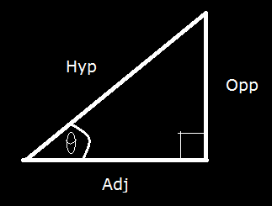
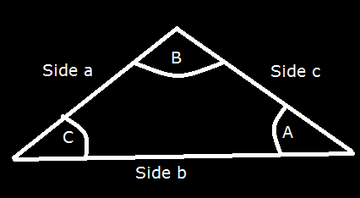
Sine and Cosine Law:
The Sine and Cosine Law are used to determine the unknown sides or angles of a triangle.
The Sine Law:
$\frac{a}{SinA}$ = $\frac{b}{SinB}$
Where a, b and c are sides of a triangle,
and A,B and C are the angles opposite to the
sides respectively.
As long as we are provided with two angles, and a side, or two sides and an angle that is opposite to either of the two sides, we can use the formula to equate all the missing information. (See questions at the bottom of the page).
There is often a large amount of confusion between the multiple forms of the Sine Law, especially in relation to right angles triangles.
If we input the variables of a right angled triangle into our Sine Law:
$\frac{Opp}{Sinθ}$ = $\frac{Hyp}{Sin(90ᶿ)}$
$\frac{Opp}{Sinθ}$ = $\frac{Hyp}{1}$
$\frac{Opp}{Hyp}$ = $Sinθ$
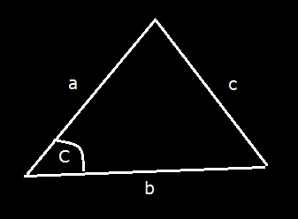
It is important that this form can only be used for right angled triangles.
The Cosine Law:
$c^{2}$= $a^{2}$+$b^{2}$ - 2.a.b.cos(C)
Where C is the angle opposite to side c.
This should be used where the lengths of sides a and b are given, but you need to equate angle C. Or when all three sides are known, and you need to calculate the interior angles.

