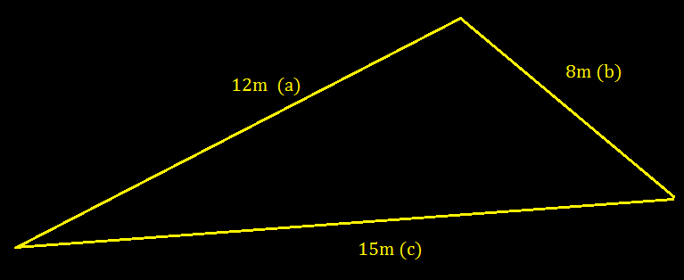
Question 3: Hard
Evaluate the interior angle which is opposite to side c.
Answer:
$95ᶿ$ = C
Working:
Firstly we write the Cosine Law.
$c^{2}$= $a^{2}$+$b^{2}$ - 2.a.b.cos(C)
We then rearrange to equate C.
$\cos^{-1}\left(\frac{c^{2}- a^{2 }- b^{2}}{- 2.a.b}\right)$ = C
Then we input our variables:
Where, a=12m, b=8m and c=15m
Therefore:
$\cos^{-1}\left(\frac{{15m}^{2}- {12m}^{2 }- {8m}^{2}}{- 2.12m.8m}\right)$ = C
$95ᶿ$ = C

