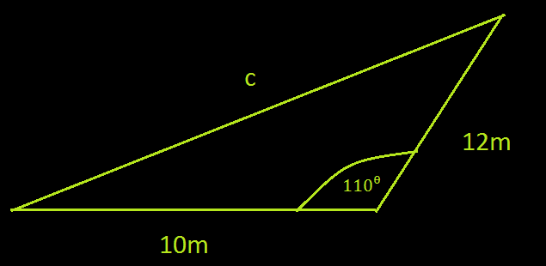
Question 2: Medium
Using the Cosine Law, calculate the length of side b.
Answer:
27.14m = b
Working:
Firstly we write the Cosine Law.
$c^{2}$= $a^{2}$+$b^{2}$ - 2.a.b.cos(C)
Then we input our variables:
We will use 12m for side a and 10m for side b. Angle C will be equal to 110ᶿ as that is the angle opposite to side c.
Therefore:
$c^{2}$= ${12}^{2}$+${10}^{2}$ - 2.12.10.cos(110ᶿ)
$c^{2}$= 326.084 m
c=18m

