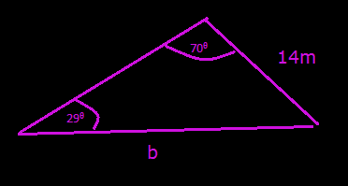
Question 1: Easy
Using the Sine Law, calculate the length of side b.
Answer:
27.14m = b
Working:
Firstly we write the Sine Law.
$\frac{a}{SinA}$ = $\frac{b}{SinB}$
Then we input our variables:
We will use 14m for side a. This will mean angle A is $29ᶿ$ as it is the angle opposite to side a.
Additionally, since the angle $70ᶿ$ is opposite to side b, it will be defined as angle B.
$\frac{14m}{Sin29ᶿ}$ = $\frac{b}{Sin70ᶿ}$
$\frac{14m}{Sin29ᶿ}$ * $Sin70$ = b
27.14m = b

