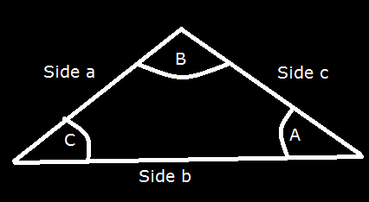
Sine and Cosine Law:
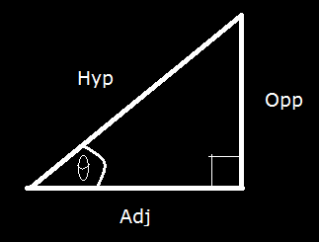
The Sine Law:
$\frac{a}{SinA}$ = $\frac{b}{SinB}$
Other forms:
$\frac{SinA}{a}$ = $\frac{SinB}{b}$ $\frac{SinA}{a}$ = $\frac{SinC}{c}$
$\frac{Opp}{Hyp}$ = $Sinθ$ $\frac{SinA}{a}$ = $\frac{SinB}{b}$ = $\frac{SinC}{c}$

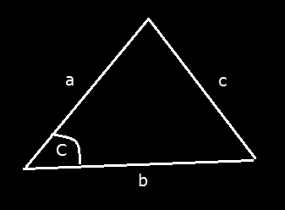
The Cosine Law:
$c^{2}$= $a^{2}$+$b^{2}$ - 2.a.b.cos(C)

